PARC Participants I’ve heard on the Tidewater DMR 31515 Talk Group

KF4HJW kf4hjw@kf4hjw.org Darrell Sutton

KN4KV me@phildrummond.com Phil Drummond

N4BC dick@n4bc.com Dick Barnes

WZ4K wz4k@arrl.net Howard Waxman

WE4TOM tom@we4tom.com Tom Taché

Some Helpful Links

DMR Registration Number

DMR ID: http://www.RadioID.net - Free

Virginia Repeaters

DMRVA: http://www.dmrva.org/

Radio Reviews

VA3XPR – Toronto, Canada: http://www.va3xpr.net/

Hams’ DMR Network

BrandMeister: https://brandmeister.network

HotSpot Software

PiStar.UK - Pi-Star Digital Voice Software: http://www.pistar.uk

Talk Groups

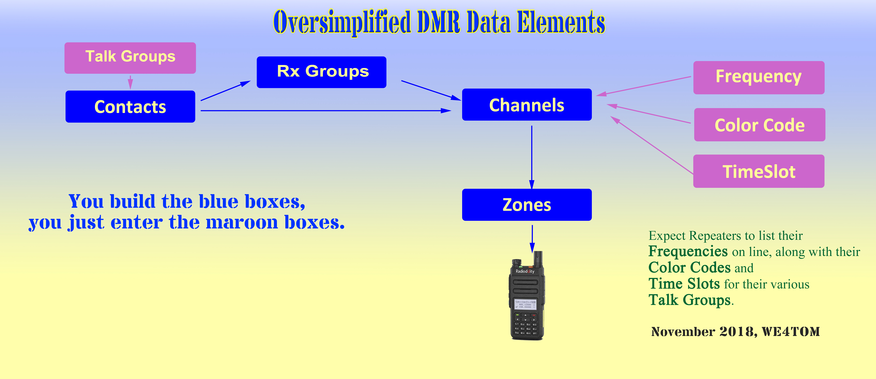BrandMeister Talk Groups: http://www.mw0mwz.co.uk/dmr_bm_talkgroups.php

|  |  |  |  |
| --- | --- | --- | --- |
| Shopping List | | | |
|  | Amazon | E-Bay | Radioddity |
| **DMR Registration Number** |  |  |  |
| DMR ID: [RadioID.net](http://RadioID.net) - Free | $0 |  |  |
| **Access to DMR Network (DMR also works Simplex)** |  |  |  |
| Access to DMR Repeater: Free | $0 |  |  |
| (Optional) DMR HotSpot: JumboSpot | $100 | $65 |  |
| **DMR Radio,** Some Popular Models |  |  |  |
| Radioddity: GD-77 | $95 | $80 | $75 |
| Baofeng: RD-5R | $80 | $75 |  |
| TYT: MD-2017 with GPS | $167 | $159 |  |
| TYT: MD-2017 without GPS | $157 | $149 |  |
| AnyTone: AT-D868UV with GPS | $179 | $179 |  |
| AnyTone: AT-D868UV without GPS |  | $159 |  |
| Prices as of 10-13-2018 |  |  |  |

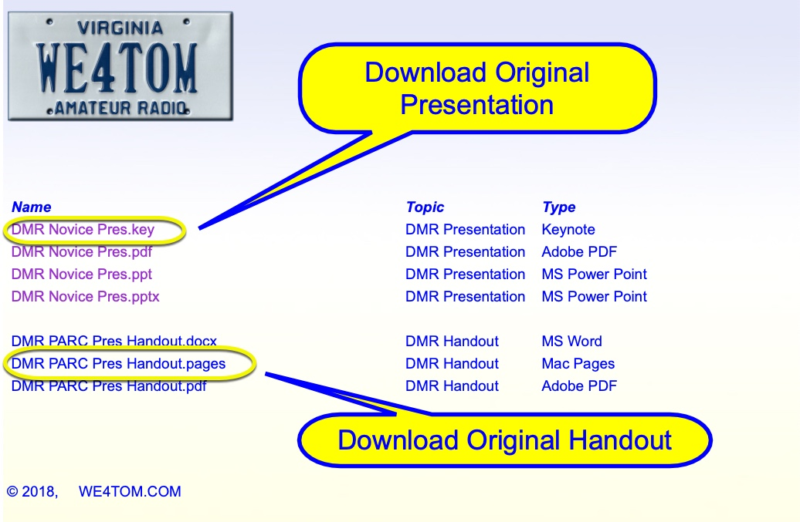

ARRL Inputs

Digital Mobile Radio (DMR) - ARRL Ohio Section: http://arrl-ohio.org/digital/digital.html

Introduction to Digital Mobile Radio (DMR):

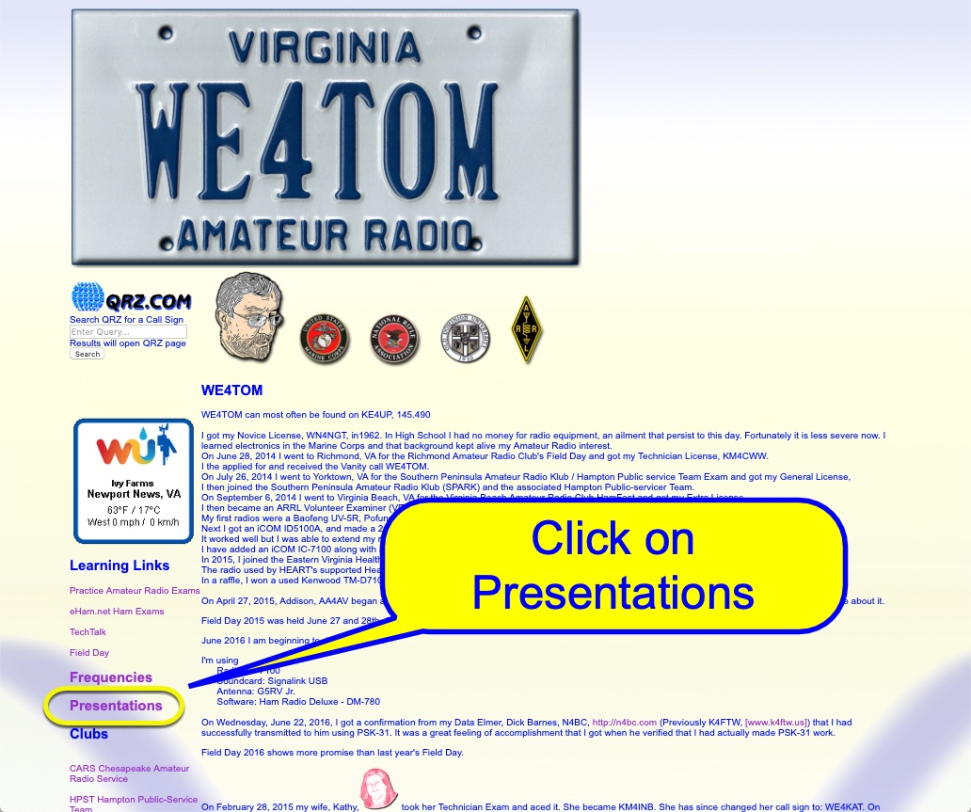

<https://www.qsl.net/kb9mwr/projects/dv/dmr/Introduction%20to%20Digital%20Mobile%20Radio.pd>f

**Download** the Powerpoint Presentation and related documents at

[www.WE4TOM.com/presentation/presentation.htm](http://www.WE4TOM.com/presentation/presentation.htm)

DMR PARC Pres Handout.pages

DMR Novice Presentation Handout

By DMR Novice: **WE4TOM**

November 2018

***Warning:*** *This document may contain sentences that use a preposition to end a sentence with. The ideas presented here DO work but are not necessarily the best ways to do any of this stuff. I am not as smart as I once thought I was.*

Operating

Select a Zone. From the Zone, select a record (Channel). Listen before talking. Catch 22. Some repeaters (or your HotSpot) require that you Kerchunk before you are recognized to hear anything on the Talk Group you want to hear. After all, until you send it information, how will it know what you want to listen to? People jumping in are likely to be stepping on QSOs in progress. To comply with FCC regulations you must identify yourself.

Tidewater DMR Net on TalkGroup 31515 Thursday Nights at 2100 Hours. WZ4K ramrods it. We are still learning. Sometimes I can’t be heard by some participants, while others can hear me. Sometimes I can’t hear some participants while others can hear them. This 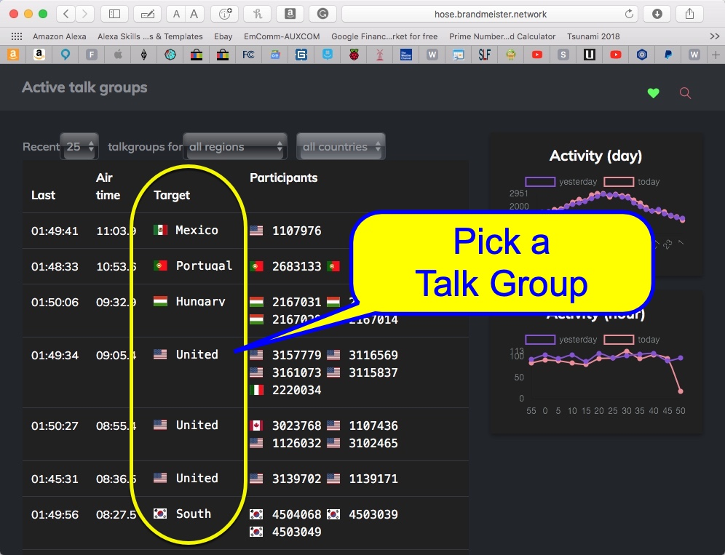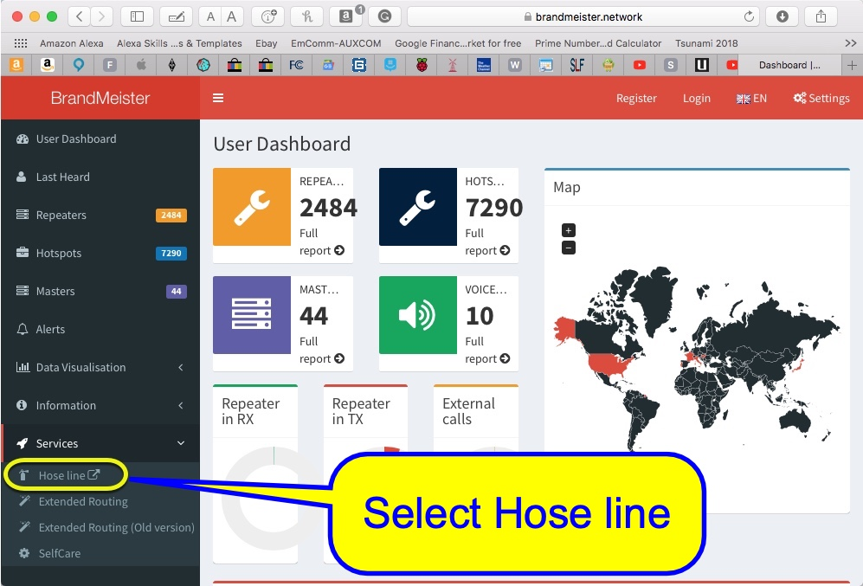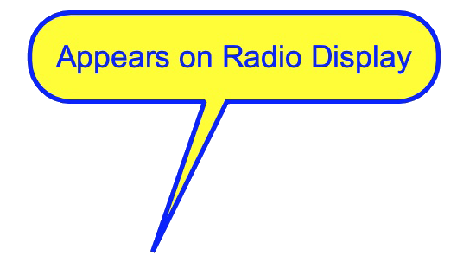tells me there is something I still don’t understand. In general, it works well. On rare occasions, in a one to one QSO, the other fellow will drop out. On occasion he’ll return, explaining what he did. I would guess that better than 90-95% of the time it is working well.

|  |  |  |  |  |
| --- | --- | --- | --- | --- |
| **Analg Rptr** | **DMR Rptr** | **HotSpot** | **Analg Smplx** | **DMR Smplx** |
| A1W4HPT | D1K4LCTTDW | H1Kat_Tom | Aa446.000 | Da441.000 |
| A1KA4VXRHpt | D1K4LCTTG2 | H1Kat310 | Aa447.000 | Da446.075 |
| A1W4MT2NN | D1K4LCTVA | H1Kat311 | Aa432.100SSB | Da433.450 |
| A1W4MT3NN | D2KK4WTI1 | H1Kat312 | Aa446.500 | Da446.500 |
| A1W4HZLGlou | D2KK4WTI310 | H1KatNat | Aa147.510X | Da145.510 |
| A1KE4UPHpt | D2KK4WTICH | H1KatPrt | Aa146.520NatCal | Da145.790 |

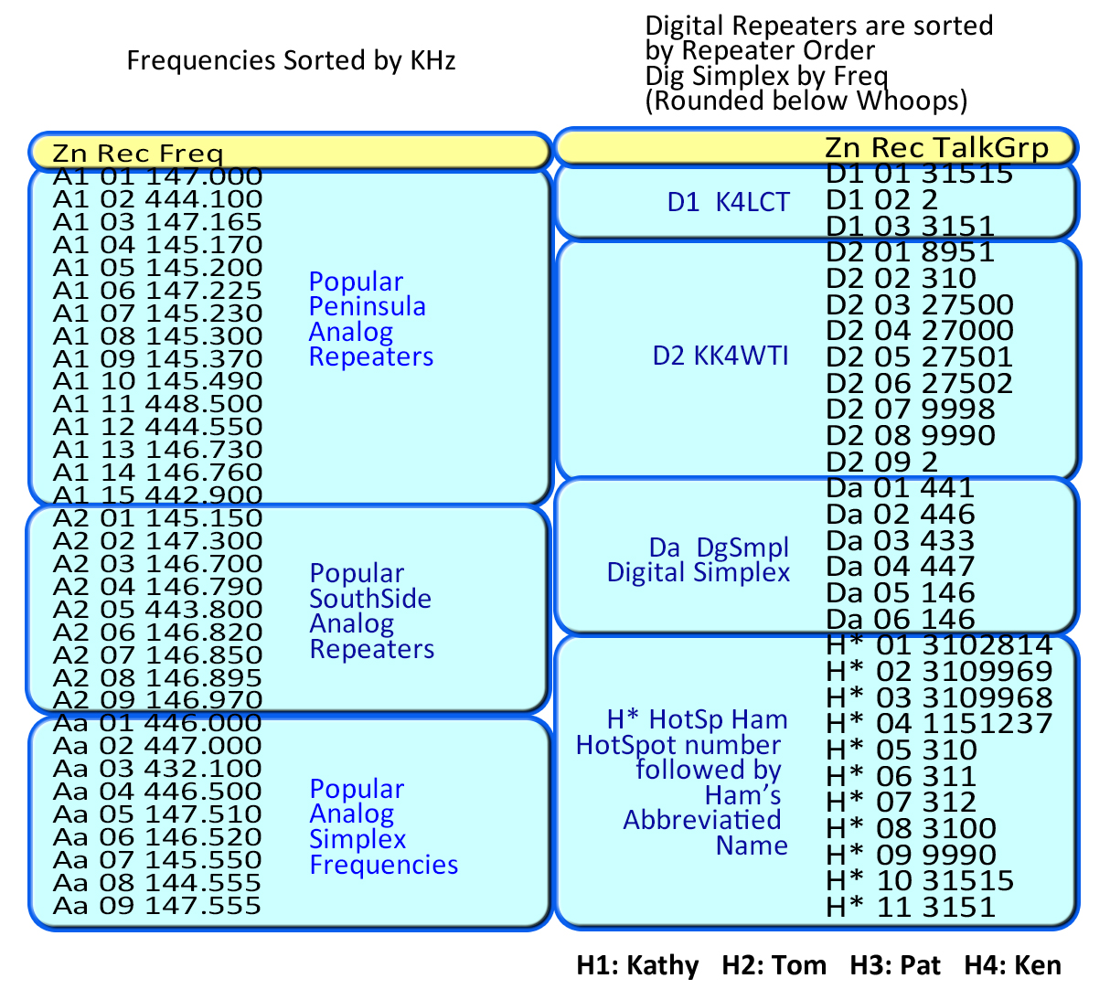

**First Character**

A: Analog

D: Digital

H: HotSpot (Also Digital)

**Second Character**

* Numeral: Identifier of a Group of Repeaters or HotSpots
* Lower Case: Sequence indicator in a Group of Simplex Frequencies

**Third through Fifth to Eighth Characters**

* Call Sign for Repeaters
* Frequency for Simplex
* Name of HotSpot

**Suffix**

**Abbr Name**

CH Chesapeake

Chspk Chesapeake

CL Clear

0P Frequency 0 KHz Peninsula

3S Frequency 3 KHz Southside

Gl Gloucester

Hpt Hampton

RN NCPRN

NN Newport News

Prt Parrot TalkGroup 9990

N1 PRN Chat 1

N2 PRN Chat 2

SSB Single Side Band

VA State VA TalkGroup 3151

1 TalkGroup 1

TG2 TalkGroup 2

310 TalkGroup 310

TDW Tidewater TalkGroup 31515

u UHF

v VHF

Wmsb Williamsburg

X WiresX

Hose Line

BrandMeister: <https://brandmeister.network>

The Hose Line will allow you to listen to live Talk Groups QSO on the internet. On occasion I have not heard, on my radio, a person I’ve been talking with, but I was able to hear him through the Hose Line. Usually, I can again hear the person on both, as the QSO / Net progresses. Mysterious? Yeah, until we figure out why.

My Zone Scheme

Inspired by a Radio Display that limits names to 10 characters.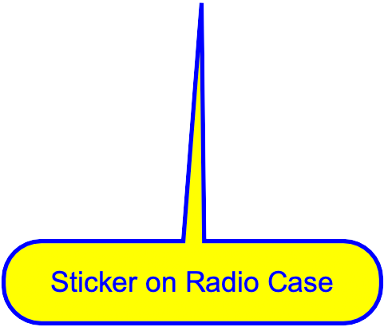

Some Channel Names